# COMP7405 Assignment 3 Report

## U3534806 and

1. **Allocation of Tasks:**
2. **UI Interface:**

The following is a complete view of UI interface:

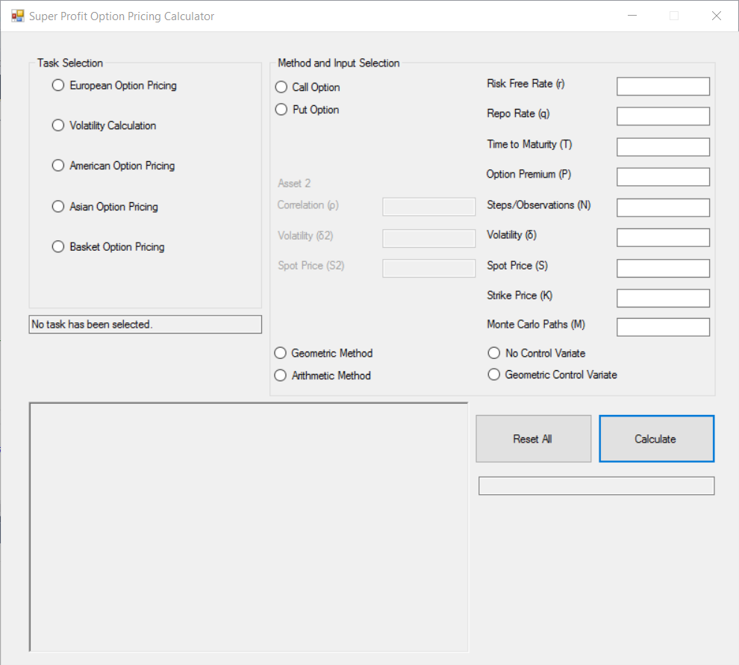

* 1. Task Selection Panel:

This panel allows user to choose the task to be performed. Only one item maybe selected at any time. With each selection, the “Method and Input Selection” panel will enable/disable input boxes/selection radios, leaving only items associated with the selected task available.

The textbox under this panel will confirm the selection.

* 1. Method and Input Selection Panel:

This panel handles data input and detailed specifications.

After data input is complete, user can press the “Calculate” button to start calculation.

If there are missing selections (e.g. missing Call or Put selection), missing data (e.g. crucial data left blank), or invalid inputs (e.g. negative Spot Price), the calculation will not proceed. User can refer to the left bottom message box to see if any item is missing or invalid.

Note for Asian Option and Basket Option, if “Geometric Method” is selected, user can leave the “Monte Carlo Paths” empty, which will calculate closed form results. If “Arithmetic Method” is chosen, the “Monte Carlo Paths” input is mandatory.

1. **Functionalities of classes/functions:**

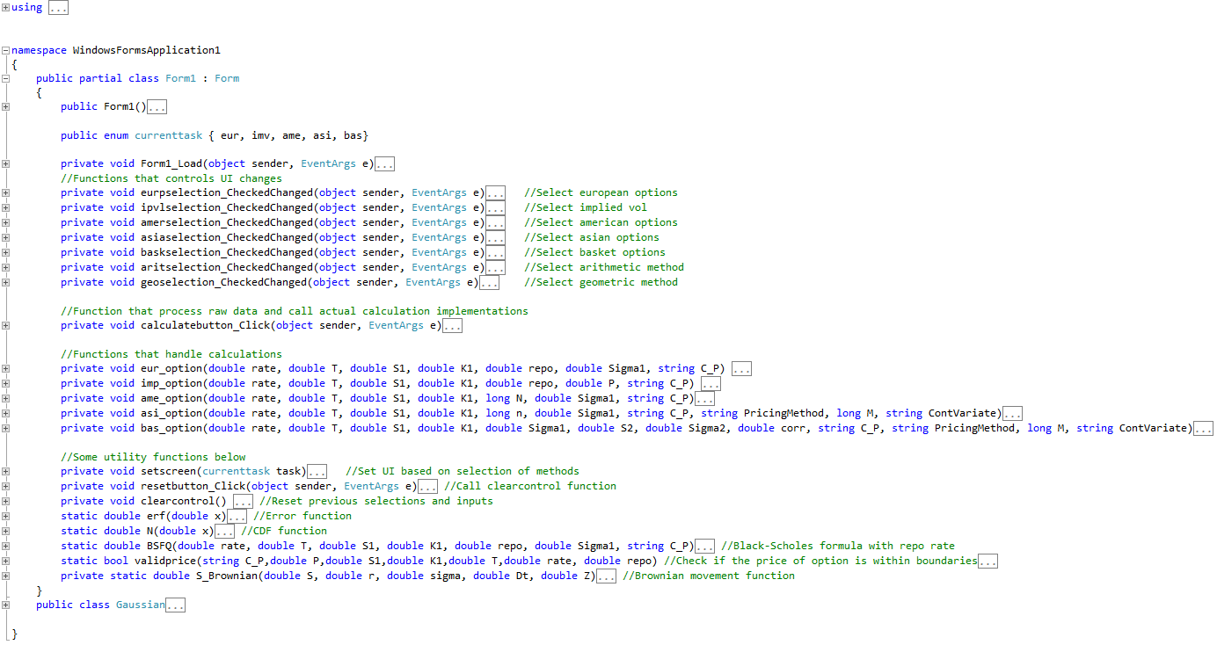

The above is a complete structure view of this program.

All “_CheckedChanged“ functions will determine a “currenttask” and call “setscreen” function, which controls UI layout according to which “currenttask” is chosen.

The “calculatebutton_Click” function handles the raw data checking and call corresponding calculation method.

All “_option” functions handle calculation with regard to option type. Inside, there are other checking for specific implementation choices such as call put, control variate, etc.

Other functions are mainly utility functions that assist UI control or calculation.

1. **Test cases and analysis:**

For all the test cases, we used r = 0:05, q=0, T = 3, and m = 100,000. We also used S(0) = 100 for Asian options and S1(0) = S2(0) = 100 for the basket options. For the basket options, we used n=1 as suggested, but the system is set up to use other values of n for instrument price movements, but still calculate for European basket options.

Geometric Asian Options

|  |  |  |  |  |  |  |  |
| --- | --- | --- | --- | --- | --- | --- | --- |
| **σ** | **K** | **n** | **Type** | **Closed-Form Formula** | **Standard MC** | **(Confidence Interval)** | |
| 0.3 | 100 | 50 | Put | 8.483 | 8.562 | 8.489 | 8.636 |
| 0.3 | 100 | 100 | Put | 8.431 | 8.484 | 8.410 | 8.557 |
| 0.4 | 100 | 50 | Put | 12.559 | 12.670 | 12.573 | 12.767 |
| 0.3 | 100 | 50 | Call | 13.259 | 13.155 | 13.026 | 13.284 |
| 0.3 | 100 | 100 | Call | 13.139 | 13.100 | 12.973 | 13.228 |
| 0.4 | 100 | 50 | Call | 15.760 | 15.634 | 15.460 | 15.807 |

* The closed form formulas came in within the 95% confidence interval for all the cases except the put with (σ=0.3, n=50). Increasing the number of steps/observations has no discernable difference on the option prices.
* For calls and puts with the same strike on the same instrument, the calls are worth more than the puts due to the risk-free rate being greater than the repo rate.
* Increasing the variance of the underlying increased the value of both puts and calls, but puts were affected slightly more. Also the range of the confidence interval increased from 0.146 to 0.194 for puts and from 0.258 to 0.348.

Arithmetic Asian Options

|  |  |  |  |  |  |  |  |  |  |
| --- | --- | --- | --- | --- | --- | --- | --- | --- | --- |
| **σ** | **K** | **n** | **Type** | **Standard MC** | **(Confidence Interval)** | | **Control Variate** | **(Confidence Interval)** | |
| 0.3 | 100 | 50 | Put | 7.876 | 7.807 | 7.946 | 7.801 | 7.797 | 7.806 |
| 0.3 | 100 | 100 | Put | 7.801 | 7.732 | 7.870 | 7.752 | 7.748 | 7.756 |
| 0.4 | 100 | 50 | Put | 11.387 | 11.297 | 11.477 | 11.284 | 11.277 | 11.292 |
| 0.3 | 100 | 50 | Call | 14.610 | 14.467 | 14.754 | 14.725 | 14.714 | 14.736 |
| 0.3 | 100 | 100 | Call | 14.562 | 14.421 | 14.704 | 14.605 | 14.594 | 14.616 |
| 0.4 | 100 | 50 | Call | 18.057 | 17.857 | 18.257 | 18.202 | 18.182 | 18.223 |

* The range for the confidence intervals for the option price with control variate are much tighter than the range for the standard monte carlo.
* Again, increasing the variance of the underlying increased the value of both puts and calls, but puts were affected slightly more. Also the range of the confidence interval increased for both the standard MC and MC with control variate.

Geometric Basket Options

|  |  |  |  |  |  |  |  |  |
| --- | --- | --- | --- | --- | --- | --- | --- | --- |
| **K** | **σ1** | **σ2** | **ρ** | **Type** | **Closed-Form Formula** | **Standard MC** | **(Confidence Interval)** | |
| 100 | 0.3 | 0.3 | 0.5 | Put | 11.492 | 11.481 | 11.383 | 11.579 |
| 100 | 0.3 | 0.3 | 0.9 | Put | 12.622 | 12.620 | 12.285 | 12.955 |
| 100 | 0.1 | 0.3 | 0.5 | Put | 6.586 | 6.578 | 6.512 | 6.645 |
| 80 | 0.3 | 0.3 | 0.5 | Put | 4.712 | 4.723 | 4.664 | 4.781 |
| 120 | 0.3 | 0.3 | 0.5 | Put | 21.289 | 21.265 | 21.129 | 21.401 |
| 100 | 0.5 | 0.5 | 0.5 | Put | 23.469 | 23.434 | 23.284 | 23.584 |
| 100 | 0.3 | 0.3 | 0.5 | Call | 22.102 | 21.986 | 21.761 | 22.211 |
| 100 | 0.3 | 0.3 | 0.9 | Call | 25.879 | 26.037 | 25.156 | 26.918 |
| 100 | 0.1 | 0.3 | 0.5 | Call | 17.925 | 17.895 | 17.742 | 18.048 |
| 80 | 0.3 | 0.3 | 0.5 | Call | 32.536 | 32.442 | 32.188 | 32.696 |
| 120 | 0.3 | 0.3 | 0.5 | Call | 14.685 | 14.556 | 14.364 | 14.749 |
| 100 | 0.5 | 0.5 | 0.5 | Call | 28.449 | 28.153 | 27.753 | 28.553 |

* The closed-form formula price was within the confidence interval for all options. The calls were more valuable than the puts for all sets except when the strike was increased to 120.
* Increasing the correlation of the underlying instruments increased the value of the options, and increased the range of the confidence interval.
* Decreasing the volatility of one of the underlying instruments decreased the value of the options, as well as the absolute range of the confidence interval. The relative range increased from around 1.7% to 2.0% for puts, but decreased from 2.0% to 1.7% for calls.
* Decreasing the strike, increased the value of calls, and decreased the value of puts. The relative confidence interval range increased from around 1.7% to 2.5% for puts and decreased from 2.0% to 1.6% for calls.
* Increasing the strike, decreased the value of calls, and increased the value of puts. The relative confidence interval range decreased from around 1.7% to 1.3% for puts and increased from 2.0% to 2.6% for calls.
* Increasing the volatility of both underlying instruments increased the value of the options, as well as the range of the confidence interval.

Arithmetic Basket Options

|  |  |  |  |  |  |  |  |  |  |  |
| --- | --- | --- | --- | --- | --- | --- | --- | --- | --- | --- |
| **K** | **σ1** | **σ2** | **ρ** | **Type** | **Standard MC** | **(Confidence Interval)** | | **Control Variate** | **(Confidence Interval)** | |
| 100 | 0.3 | 0.3 | 0.5 | Put | 10.569 | 10.474 | 10.664 | 10.579 | 10.567 | 10.591 |
| 100 | 0.3 | 0.3 | 0.9 | Put | 12.442 | 12.337 | 12.547 | 12.427 | 12.425 | 12.430 |
| 100 | 0.1 | 0.3 | 0.5 | Put | 5.518 | 5.460 | 5.575 | 5.524 | 5.516 | 5.533 |
| 80 | 0.3 | 0.3 | 0.5 | Put | 4.255 | 4.247 | 4.262 | 4.255 | 4.247 | 4.262 |
| 120 | 0.3 | 0.3 | 0.5 | Put | 19.858 | 19.725 | 19.992 | 19.882 | 19.865 | 19.898 |
| 100 | 0.5 | 0.5 | 0.5 | Put | 21.054 | 20.907 | 21.200 | 21.087 | 21.059 | 21.115 |
| 100 | 0.3 | 0.3 | 0.5 | Call | 24.372 | 24.132 | 24.611 | 24.494 | 24.462 | 24.525 |
| 100 | 0.3 | 0.3 | 0.9 | Call | 26.177 | 25.903 | 26.451 | 26.350 | 26.344 | 26.356 |
| 100 | 0.1 | 0.3 | 0.5 | Call | 19.405 | 19.233 | 19.577 | 19.438 | 19.419 | 19.457 |
| 80 | 0.3 | 0.3 | 0.5 | Call | 35.282 | 35.014 | 35.549 | 35.380 | 35.348 | 35.413 |
| 120 | 0.3 | 0.3 | 0.5 | Call | 16.447 | 16.239 | 16.655 | 16.585 | 16.555 | 16.615 |
| 100 | 0.5 | 0.5 | 0.5 | Call | 34.669 | 34.203 | 35.135 | 35.005 | 34.896 | 35.113 |

* The confidence intervals for all options overlapped, and the value of the calls was greater than the puts in all cases except when the strike was increased to 120.
* Like the Asian options, the confidence interval was much tighter when using the control variate than the standard MC.
* The option price reaction to changing inputs on arithmetic basket options was similar to geometric options.